**Comparison between AWS and GCP**

[**https://chatgpt.com/share/67f5fff5-905c-800d-b767-1abb1d829204**](https://chatgpt.com/share/67f5fff5-905c-800d-b767-1abb1d829204)

**Compute Services**

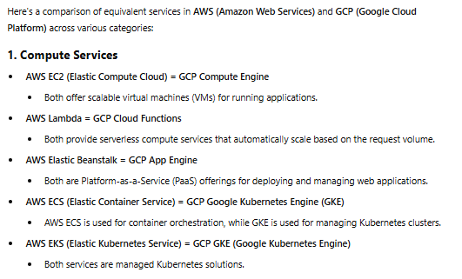

**Storage Services**

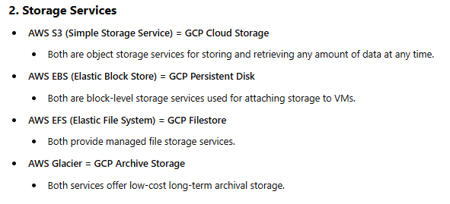

**Networking**

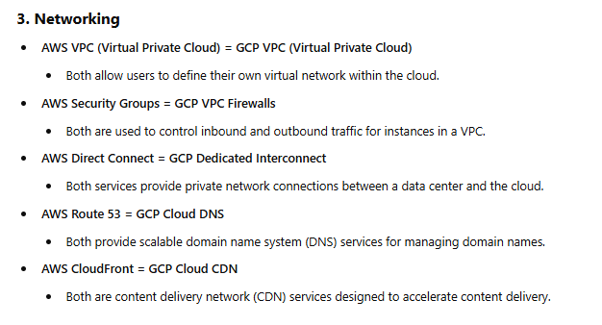

**DataBases**

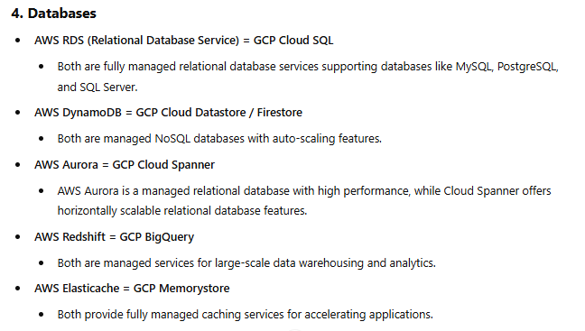

**IAM**

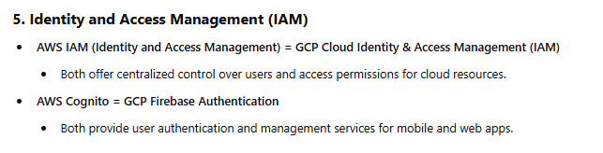

**Data Analysis**

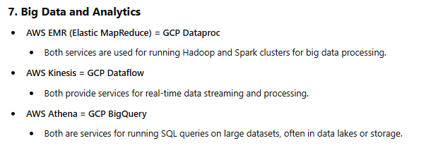

**Montioring and Management**

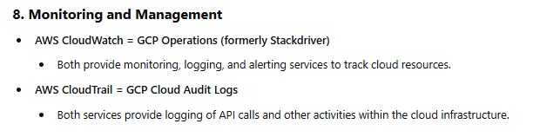

**Security Services**

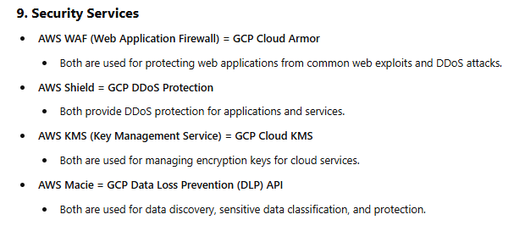

**Developer Tools**

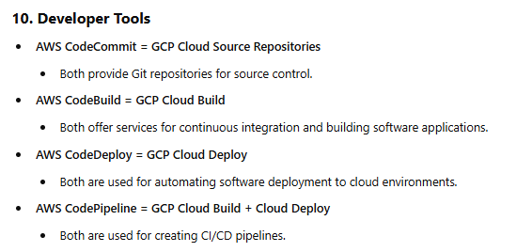

**Serverless**

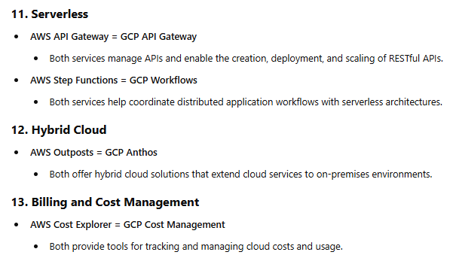

**Ai and ML**

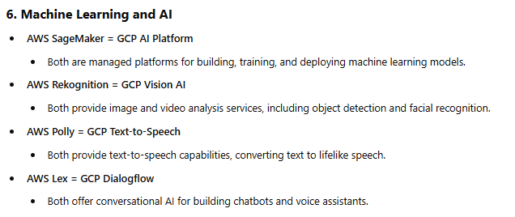

**Difference between AWS and GCP   
Security group and auto scaling**

**Security group = VPC firewalls , tags , service accounts  
Prompt in ChatGpt :   
  
what is the equivalent of security groups and auto scaling of AWS compared to GCP, please tell me in details of their equivalent in GCP**[**https://chatgpt.com/share/67f4b084-3f00-800d-bb23-2270bdeca642**](https://chatgpt.com/share/67f4b084-3f00-800d-bb23-2270bdeca642)

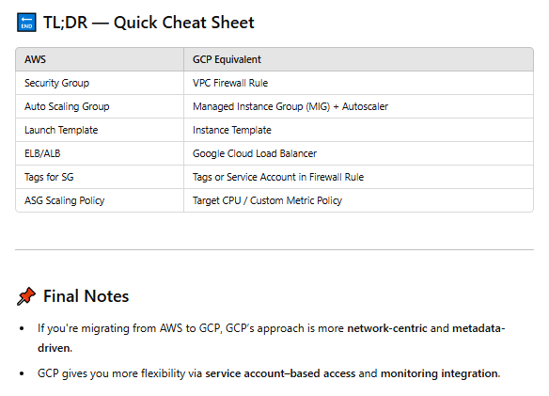

**BeanSTalk in AWS vs GCP Google cloud app Engine ( GAE )**

